

**GREATER NOIDA INSTITUTE OF TECHNOLOGY**

DEPARTMENT OF

ELECTRONICS AND COMMUNICATION

A SYNOPSIS ON:

**UAV Surveillance System using ATMega328p Microcontroller**

**and Raspberry Pi**

By:

Prabhat Kumar Mishra -1901320310057

Pragya Pandey-1901320310058

Sameer Ansari-1901320310072

Swarm Sapra-1901320310079

A Research proposal

Under the Supervision of

**Dr. MUKESH OJHA(HOD)**

**CONTENTS**

* Introduction
* Literature Survey
* Objective
* Proposed Model
* Hardware and Software Used
* Working Methodology
* Conclusion
* References

**INTRODUCTION**

The most powerful technology available for tracking vehicles and individuals is [unmanned aerial vehicles](https://www.sciencedirect.com/topics/computer-science/unmanned-aerial-vehicle) (UAVs), also referred to as [drones](https://www.sciencedirect.com/topics/computer-science/drones). [Drones](https://www.sciencedirect.com/topics/computer-science/drones) are aircraft that do not carry human operators. They are controlled either remotely or autonomously, based upon a preprogrammed flight path. They are small and large. They can be equipped with high-powered cameras, thermal scanners, license plate readers, moving target indicators, laser radar (LADAR), light detection and ranging (LIDAR), and facial recognition software. There has been a rapid development of drones for the past few decades due to the advancement of components such as micro-electro-mechanical systems (MEMS), Flight controllers, sensors, microprocessors, high energy Lithium Polymer (LiPo) batteries, as well as more efficient and compact actuators. Drones are now present in many daily life activities. They are used in many applications such as inspecting pipelines and power lines, surveillance and mapping, military combat, agriculture, delivery of medicines in remote areas, aerial mapping, and many others. Robotic manipulators, found in many applications, have in recent years drones implemented on UAV platforms for tasks such as aerial manipulation, grasping, and cooperative transportation.

The unstable dynamics of the robotic arm, which increase the control complexity of UAVs, have widely been studied in the literature. UAV technology is rapidly growing while UAV solutions are being proposed at faster rates as various needs arise. Drone features are determined by specific UAV applications as well as competition in the commercial market. A review of the most recent applications of UAVs in the cryosphere [1] was conducted. Compared to conventional spaceborne or airborne remote sensing platforms, UAVs offer more advantages in terms of data acquisition windows, revisits, sensor types, viewing angles, flying altitudes, and overlap dimensions. The review shows that across the world, applications used various multirotor and fixed-wing UAV platforms.

[Drone surveillance](https://flytnow.com/security-and-surveillance/) refers to the act of keeping a visual track of an individual, a group, an object, or a situation for the purpose of thwarting any kind of threat. An effective surveillance system using drone fleets requires seamless integration between reliable hardware and intelligent automation software. Below are the generic components of such a system. The purpose is to design a system capable of capturing real-time images automatically from the infrared camera and with fewer human interactions using IoT-based technology. The UAV system is equipped with the main flight controller, an infrared camera, and Raspberry Pi as IoT and processing platform. The IoT system conveys to the ground control station (GCS) the image of the detected object or person and the global positioning system (GPS) location. The system combines IoT, and live image and video feedback to control the camera for surveillance.

**OBJECTIVE**

This synopsis is turning around an Unmanned Aerial Vehicle (UAV) surveillance system based on ATMega328p microcontroller and Raspberry Pi. The aim of this synopsis is to develop an appropriate system for such a machine and to complete control architecture which will allow the UAV to act as surveillance system. Using these features, we develop our UAV for surveillance purpose for a specific period of time. An UAV (Unmanned Aerial Vehicle) with precise payloads can hover straight above the monitoring Lines or monitoring Sites to record video of the area, as well as thermal images that are then geo-tagged and communicated in real-time to the ground station using the planning and monitoring. It is not possible for humans to reach every specific location, do surveillance and take security measures. In this case, surveillance can be done using a helicopter but it consumes a huge amount of fuel thus it is costly. In addition, as the size of the helicopter is bigger it cannot hover in a narrow space and if any accidents happen then a lot of money will be destroyed as well. In contrast, electric-powered drone consumes very low power and cost plus they can hover in tiny spaces as it is small in size. So, it is more efficient and environmentally friendly.

**LITERATURE SURVEY**

* **Basic UAV System Approach**
* The [2] paper presents a methodology of an Aerial UAV surveillance system. The proposed model was designed for surveillance in civil and military areas. They also presented an approach to custom mission planning through GPS waypoint navigation. The quadcopter was made to fly through a series of customized waypoints. These waypoints were designed at a ground station and then sent to the drone via a connection between the UAV and the ground system.
* A model was proposed, implemented, and evaluated for the ACODS (Adaptive Computation Offloading for Drone Surveillance System) [3] design to improve the energy efficiency and response time for military drone surveillance applications. Performance results in various scenarios resulted that ACODS providing significantly improved drone performance for tactical surveillance operations compared with local computing.
* A developed amateur drone surveillance system based on cognitive IoT was proposed [4]. They first presented a brief survey on state-of-the-art studies on anti-drone techniques and proposed a vision named Dragnet by tailoring the recent emerging cognitive IoT framework for amateur drone surveillance.
* **Flight Controllers based on Arduino**
* This paper [5] presents an inexpensive and affordable Arduino Uno-based flight controller for Quadcopters that was designed and developed. It was equipped with GPS and other sensors for stable and controlled flight.
* This paper [6] elaborates on the use of Arduino-Uno and MPU-6050 gyro/accelerometer in the field of custom flight controllers. YMFC-AL [7] Opensource flight controller program was used to program the Arduino-based flight controller and a self-balancing drone was developed. It was able to maintain its axis according to XYZ plains.
* **Addition of IoT**
* In addition, Saifeddine Benhadhria and his team [8] developed an Intelligent and Fully Automatic Drone Based on Raspberry Pi. It had automatic piloting from the Raspberry Pi 3B+ with Android embedded in the Ubuntu server. It detected obstacles during its navigation, and it offered live streaming while respecting the constraints of memory, real-time performance, and security.

**PROPOSED MODEL**

The proposed system is an efficient UAV surveillance system complemented with Flight controller , Infrared camera and main IoT processing unit. The UAV is carried out at the surveillance area where security is needed, it can be exceptionally confined regions like military zones, government areas, or private properties and workplaces. The UAV initially recognizes the threats using an image processing technique and afterward catches the picture. The data is then uploaded to the cloud through a connected network and is fetched by the Ground Station. The Image processing and recognition are to be implemented and simulated using Python and Deep Learning.

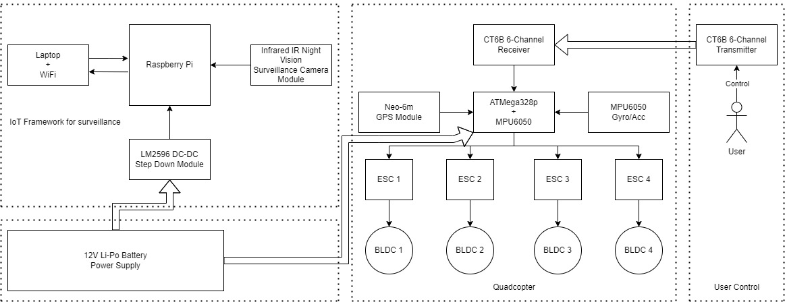

**Fig. 1.** Proposed Model

**Hardware Used**

* **BLDC motors 1000kv**

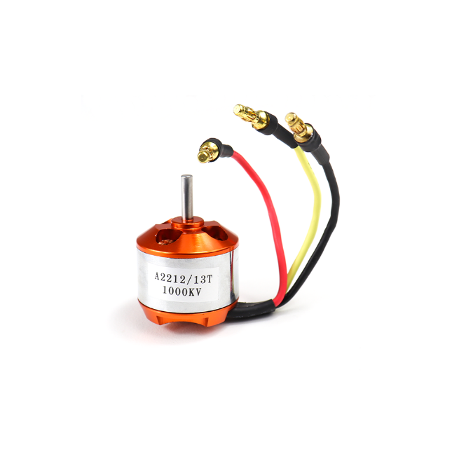

**Fig. 2.** BLDC Motor

A2212 brushless outrunner motor specifically made to power Quadcopters and Multirotor. It is a 1000kV motor. It provides high performance, super power and brilliant efficiency. These motors are perfect for medium size quadcopters with 8 inch to 10-inch propellers. With 3S LiPo battery, 30A ESC and high efficiency 10" propellers these motors provide up to 800gms of payload. A total of 4 of these motors on a quadcopter with propellers provide a total of 3.2 kg of weight lifting capacity.

Specifications: -

* KV: 1000kv
* No-load Current: 10 V: 0.5 A.
* Current Capacity: 12A/60s
* No Load Current @ 10V: 0.5A
* No. Of Cells: 2-3 Li-Poly
* Motor Dimensions: 27.5 x 30mm
* Shaft Diameter: 934;3.17mm
* Shaft diameter: 3.175mm.
* Minimum ESC Specification: 18A
* Maximum ESC Specification: 30A
* **ESC controllers**

Simonk 30A BLDC ESC Electronic Speed Controller is specifically made for quadcopters and multi-rotors. Which provides faster and better motor speed control giving better flight performance compared to other available ESCs.

Simonk 30A BLDC ESC Electronic Speed Controller can drive motors that consume current up to 30A. It works on 2S-3S LiPo batteries. This electronic speed controller offers a battery eliminator circuit (BEC) that provides 5V and 2A to the receiver.

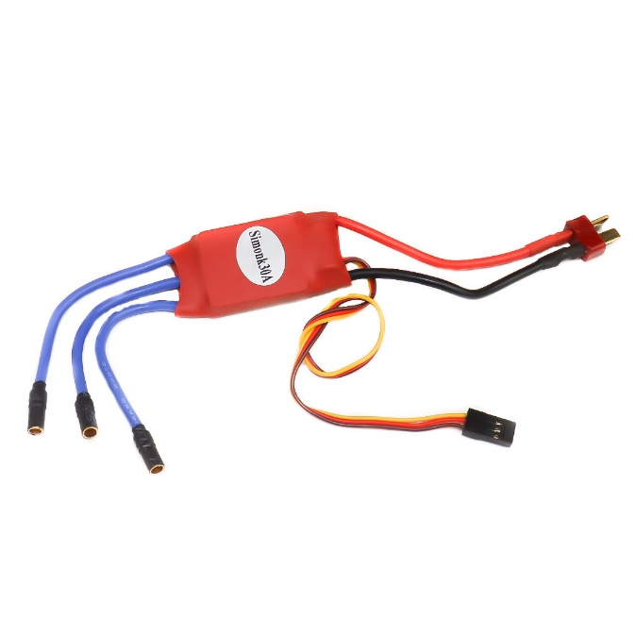

**Fig. 3.** Simonk ESC 30A

* **Propellors**

1045 Propellers. Set of 4 includes two clockwise rotating and two counter-clockwise rotating propellers with 4 x propeller shaft adapters. The adapters allow the propeller to be used with motors of different shaft diameters.

This 1045 propeller can be used with brushless motors with an 800-2200 kV rating. With a low kV motor (800 - 1400 kV), this propeller offers smooth flights with longer flight times perfect for FPV and aerial photography. With a high kV motor (more than 1200 kV) this propeller offers fast flights perfect for acrobatic flights.

This propeller can be used with our A2212 1000KV, 1400KV, 1800KV, and 2200kV motors and with 30A ESC.

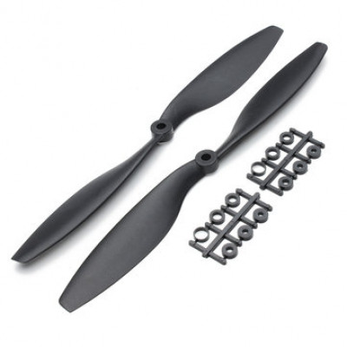

**Fig. 4.** 1045 Propellors

* **Arduino UNO with ATMega328p Microcontroller**

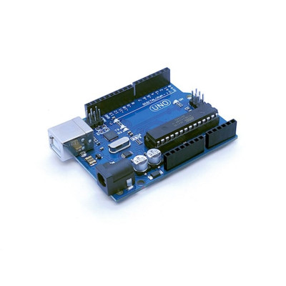

**Fig. 5.** Arduino UNO with ATMega3286p

The Uno R3 is an open-source microcontroller board based on the ATmega328 chip. This Board has 14 digital input/output pins, 6 analog input pins, Onboard 16 MHz ceramic resonator, Port for USB connection, Onboard DC power jack, An ICSP header and a microcontroller reset button. It contains everything needed to support the microcontroller. Using the board is also very easy, simply connect it to a computer with a USB cable or power it with a DC adapter or battery to get started.

The Uno differs from all preceding boards in that it does not use the FTDI USB-to-serial driver chip. Instead, it features the Atmega16U2Atmega8U2 up to version R2) programmed as a USB-to-serial converter. While the UNO can be powered via the USB connection or with an external power supply, the power source is selected automatically.

External (non-USB) power can come either from an AC-to-DC adapter (wall-wart) or a battery. The adapter can be connected by plugging a 2.1mm center-positive plug into the board's power jack. Also leads from a battery can be inserted in the GND and Vin pin headers of the Power connector. The board can operate on an external supply of 6 to 20 volts. If supplied with less than 7V, however, the 5V pin may supply less than five volts and the board may be unstable. If using more than 12V, the voltage regulator may overheat and damage the board. The recommended range is 5v to 12v for Uno.

* **Li-Po Battery 12.6 V 2200mah**

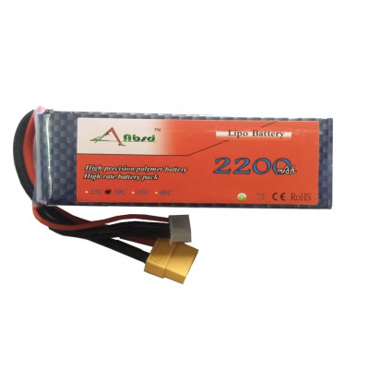

**Fig. 6.** Li-Po Battery 12.6 V 2200mah

12.6V 2200mAH Li-Po battery, Capable of maximum continuous discharge rates up to 25C.

Specifications:

* Charge Capacity (C): 2200mAh.
* Rated Voltage: 11.1V
* Exact weight: 150 - 160 Grams
* LxHxW: 100*20*30mm Approx
* **Raspberry Pi**

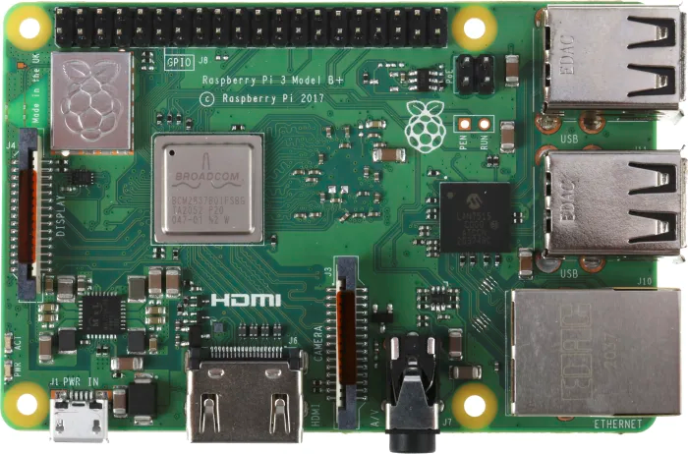

**Fig. 7.** Raspberry Pi Model 3B+

The Raspberry Pi 3 Model B is the third generation Raspberry Pi. This powerful credit-card sized single board computer can be used for many applications and supersedes the original Raspberry Pi Model B+ and Raspberry Pi 2 Model B. It brings more powerful processor, 10x faster than the first-generation Raspberry Pi.

Additionally, it adds wireless LAN & Bluetooth connectivity making it the ideal solution for powerful connected designs.

Specifications:

Broadcom BCM2387 chipset

* 1.2GHz Quad-Core ARM Cortex-A53
* 802.11 b/g/n Wireless LAN and Bluetooth 4.1 (Bluetooth Classic and LE)
* 1GB RAM
* 64 Bit CPU
* 4 x USB ports
* 4 poles Stereo output and Composite video port
* Full-size HDMI
* 10/100 Ethernet socket
* CSI camera port for connecting the Raspberry Pi camera
* DSI display port for connecting the Raspberry Pi touchscreen display
* Micro SD port for loading your operating system and storing data
* Micro USB power source
* **Raspberry Pi 5MP Camera Module**

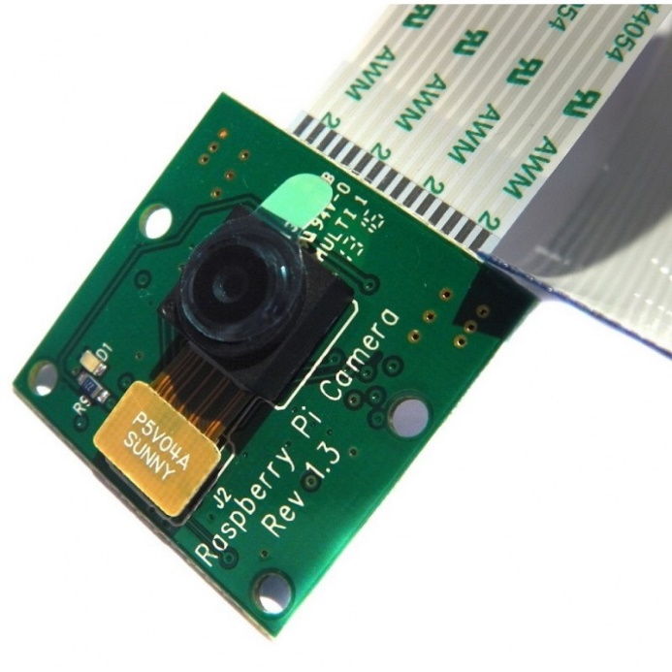

**Fig. 8.** Raspberry Pi 5MP Camera Module

The 5MP Raspberry Pi 3 Model B Camera Module with Cable equips flexible cable for attaching with Raspberry Pi 3 Model B.

The high-definition 5MP camera delivers outstanding photos but can also shoot video, ideal for drones or CCTV projects. The lightweight camera module allows for it to be used in more practical roles, such as a hidden camera or even a camera for a Pi-phone, for example.

The board itself is tiny, at around 25mm x 23mm x 8mm. It also weighs just over 3g, making it perfect for mobile or other applications where size and weight are important. It connects to Raspberry Pi by way of a short flexible ribbon cable. The camera connects to the BCM2835 processor on the Pi via the CSI bus, a higher bandwidth link that carries pixel data from the camera back to the processor. This bus travels along the ribbon cable that attaches the camera board to the Pi.

**SOFTWARE USED**

* **Adreno IDE**



**Fig. 9.** Adreno Logo

The Arduino Integrated Development Environment - or Arduino Software (IDE) - contains a text editor for writing code, a message area, a text console, a toolbar with buttons for common functions and a series of menus. It connects to the Arduino hardware to upload programs and communicate with them.

Programs written using Arduino Software (IDE) are called sketches. These sketches are written in the text editor and are saved with the file extension ‘.ino’. The editor has features for cutting/pasting and for searching/replacing text. The message area gives feedback while saving and exporting and also displays errors. The console displays text output by the Arduino Software (IDE), including complete error messages and other information. The bottom righthand corner of the window displays the configured board and serial port. The toolbar buttons allow you to verify and upload programs, create, open, and save sketches, and open the serial monitor.

**WORKING METHODOLOGY**

## **System Architecture**

We designed the system using an ATMega328p microcontroller as the main flight controller and a 12V Li-Po battery for powering the quadcopter. The flight Controller will consist of an ATMega328p microcontroller and MPU-6050 gyro/accelerometer. Using Arduino Uno or Arduino Pro mini with a separate sensor module fits the situation. A modified version of the YMFC-AL program [9] is used to program the flight controller.

Designing a Flight-Controller from Arduino and MPU6050 module presents the following challenges:

* Due to differences in size and differences in the structure of both modules they are heavily prone to noise due to the vibration from the motors.
* Jumping wires are used for connecting the sensor to the Arduino board creating interference and glitches during measurements resulting in low accuracy.
* Accurate response time prediction and calculation for drone stability.

For overcoming these challenges, we have used CRIUS Multiwii 2.5 SE flight controller module which has both ATMega328p and MPU6050 mounted onboard and supports an open-source platform. It also has a step-down module built in for providing 12V to 5V/3V power supply for both the microcontroller and sensor.

The IoT framework will consist of Raspberry Pi and an IR camera is connected to the module. For powering up the Raspberry Pi, a step-down module is used for producing stable 5.2 V output from the 12V main power supply.

The operating system is Raspberry Pi OS (32-bit) and is used for capturing and transmitting live video and images through SSH to the laptop or the ground station. The live feed can be seen through a terminal command especially running through SSH which decreases security risks.

Drone path and location are controlled from the ground station and the communication system is based on (RF) radio frequency. RF Module having 2.4GHz frequency is used to transmit signals from the 1ground station and receive signals by the UAV system.

GPS drones are equipped with a GPS module inside the drone, allowing them to know their position relative to a network of orbiting satellites. Our Quadcopter has GPS navigation to detect violations of humans and wild animals in the protected area.

Location is sent to the ground station using latitude and longitude values captured from the Neo-6m GPS module. From this data, we can see the live location of the drone and correct its position or get the location of the threat.

## **Flight Controller and IoT Flow Diagram**

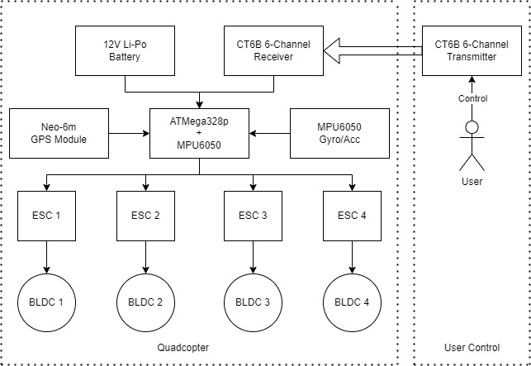

**Fig. 10.** Quadcopter system flow diagram

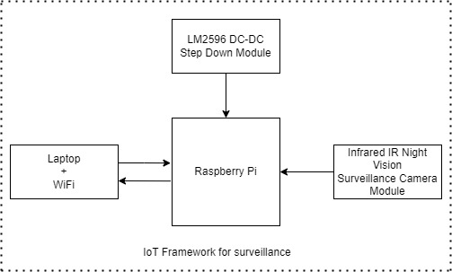

**Fig. 11. IoT system flow diagram**

**CONCLUSION**

This synopsis provides an inexpensive and affordable cost for the successful development of the ATMega328p-and Raspberry Pi-based surveillance Quadcopter. A Quadcopter which is easy to generate unit components. Our Quadcopter can be used for surveillance in civil and military areas. It can be used for monitoring a campus, office, and industrial areas by various institutions, for monitoring the borders and peacekeeping activities by the government, and can also be used to monitor private properties by individuals. It can be used as a low-price alternative for many other applications.

**References**

1. Gaffey, Clare, and Anshuman Bhardwaj. 2020. "Applications of Unmanned Aerial Vehicles in Cryosphere: Latest Advances and Prospects" Remote Sensing 12, no. 6: 948. <https://doi.org/10.3390/rs12060948>
2. Zaheer, A. Usmani, E. Khan and M. A. Qadeer, "Aerial surveillance system using UAV," 2016 Thirteenth International Conference on Wireless and Optical Communications Networks (WOCN), 2016, pp. 1-7, doi: 10.1109/WOCN.2016.7759885.
3. W. -S. Jung, J. Yim, Y. -B. Ko and S. Singh, "ACODS: adaptive computation offloading for drone surveillance system," 2017 16th Annual Mediterranean Ad Hoc Networking Workshop (Med-Hoc-Net), 2017, pp. 1-6, doi: 10.1109/MedHocNet.2017.8001647.
4. G. Ding, Q. Wu, L. Zhang, Y. Lin, T. A. Tsiftsis and Y. -D. Yao, "An Amateur Drone Surveillance System Based on the Cognitive Internet of Things," in IEEE Communications Magazine, vol. 56, no. 1, pp. 29-35, Jan. 2018, doi: 10.1109/MCOM.2017.1700452
5. Basheer Ahamed M, Muruganand S, Padmasine K G and Manikandan N, “A Real Time Surveillance Application using Microcontroller Based Quadcopter” , PP: 2611-2614 | Volume-8 Issue-1, May 2019 | Retrieval Number: A1087058119/19©BEIESP.
6. Dutta, Arijit. (2020). Self-Balancing Multipurpose Quadcopter for Surveillance System. International Journal for Research in Applied Science and Engineering Technology. 8. 381-384. 10.22214/ijraset.2020.5063.
7. Joop Brokking, http://www.brokking.net/ymfc-al_main.html [Accessed Date 22 November 2022].
8. Benhadhria, Saifeddine, Mohamed Mansouri, Ameni Benkhlifa, Imed Gharbi, and Nadhem Jlili. 2021. "VAGADRONE: Intelligent and Fully Automatic Drone Based on Raspberry Pi and Android" Applied Sciences 11, no. 7: 3153. https://doi.org/10.3390/app11073153
9. https://github.com/pkm774/Raspberry-Pi-Arduino-UNO-Drone/tree/main/Flight%20Controller [Accessed Date 23 December 2022]